**PAWS AND PALS**

PET ADOPTION CENTRE

# **Submitted by:**

# ***Team Members****- Anushka Pravakar , Krupa Anna Chandy ,Shrayana KS*

***Roll Number****- 2462045 , 2462104 , 2462149*

***College****-* [*anushka.pravakar@btech.christuniversity.in*](mailto:anushka.pravakar@btech.christuniversity.in)

[*krupa.anna@btech.christuniversity.in*](mailto:krupa.anna@btech.christuniversity.in)

[*shrayana.k@btech.christuniversity.in*](mailto:shrayana.k@btech.christuniversity.in)

***Course****: UI/UX Design Fundamentals*

***Instructor Name****: Nagaveena*

***Institution****: Christ University Kengeri Campus*

*·****Date of Submission****: 13/08/2025*

**ABSTRACT**

Paws & Pals is a web-based platform created to connect animal shelters with individuals seeking to adopt pets. The project’s main goal is to make the adoption process simple, transparent, and accessible by offering a clean, mobile-friendly interface where users can browse detailed pet profiles, filter by species, age, or temperament, and view important details such as health status and vaccination records. Built entirely with semantic HTML for structure and responsive CSS for adaptability, the site ensures smooth navigation and compatibility across devices while following accessibility guidelines. The final outcome is an intuitive and visually appealing adoption portal that helps shelters showcase their animals effectively and enables adopters to make informed choices. This project highlights how well-structured, lightweight web design can be used to address social needs and encourage responsible pet adoption.

**OBJECTIVES**

* Design a user-friendly interface using modern UI principles
* Develop a fully responsive layout using only HTML and CSS
* Implement structured HTML5 semantic elements
* Apply CSS styling for branding, layout, and responsive behavior
* Ensure accessibility and readability across devices

**SCOPE OF THE PROJECT**

The Paws & Pals – Pet Adoption project is developed as a front-end–focused web platform, concentrating solely on the visual design, structure, and styling of a pet adoption website. It does not incorporate JavaScript, dynamic features, or any server-side processing; all pages and content are static, created for demonstration and presentation purposes only. The design is fully responsive, ensuring that the layout adapts seamlessly to desktop, tablet, and mobile viewports for a consistent user experience across devices. The development process relies entirely on open-source tools and pure, hand-written HTML and CSS, with no third-party frameworks, libraries, or proprietary software involved. This approach highlights the importance of clean, semantic markup and responsive design techniques while maintaining complete control over the codebase. The project includes essential adoption-related sections such as home, about, pet listings, contact information, and adoption guidelines. While the current version focuses on the static representation of these pages, it is structured to allow future integration of dynamic functionalities, databases, and interactivity if expanded into a full-featured application. Overall, the scope is deliberately narrow to demonstrate front-end proficiency, accessibility best practices, and effective design principles, serving as a solid foundation for a more comprehensive adoption portal in the future.

# **TOOLS & TECHNOLOGIES USED**

|  |  |
| --- | --- |
| **Tool/Technology** | **Purpose** |
| **HTML5** | **Markup and content structure** |
| **CSS3** | **Styling and layout management** |
| **VS Code** | **Code editor** |
| **Chrome DevTools** | **Testing and debugging** |

**KEY FEATURES**

|  |  |
| --- | --- |
| **Feature** | **Description** |
| **Responsive Design** | **Adapts seamlessly to all screen sizes** |
| **Smooth Navigation** | **Fixed top nav with anchor links** |
| **Project Cards** | **Flex-based layout with hover effects** |
| **Contact Form (non-functional)** | **Placeholder layout for inputs and button** |
| **Accessible Fonts & Colors** | **High contrast and readable typography** |

**CHALLENGES FACED AND SOLUTION**

|  |  |
| --- | --- |
| **Challenge** | **Solution** |
| **Overlapping elements on small screens** | **Used media queries to stack elements** |
| **Difficulty aligning items using float** | **Shifted to Flexbox and Grid** |
| **Typography scaling issue** | **Used relative units (em/rem) instead of px** |

**OUTCOME**

The Paws & Pals – Pet Adoption project has resulted in the creation of a clean, consistent, and visually appealing front-end design that effectively communicates the purpose of an online pet adoption platform. Every planned component—such as the homepage, detailed pet profiles, adoption guidelines, and contact information—was designed and presented using only semantic HTML and responsive CSS, ensuring functionality without the need for JavaScript or server-side elements. The layout remains uniform across the site, with deliberate attention to typography, color schemes, and visual balance to maintain a professional and engaging appearance. A key success of the project lies in achieving full responsiveness, enabling the website to adapt seamlessly to various screen sizes including desktop, tablet, and mobile devices. Throughout the process, there was a strong focus on learning and applying UI hierarchy principles, ensuring that important information is easily accessible and naturally guides the visitor’s attention. The experience also reinforced skills in structuring content logically, optimizing for accessibility, and building without external libraries or frameworks. Ultimately, the project demonstrates that a well-crafted static site can deliver both usability and aesthetic value, while providing a scalable foundation for future development, such as integrating interactive features, user accounts, or live adoption databases.

**FUTURE ENHANCEMENT**

While the current version of the Paws & Pals – Pet Adoption project successfully meets its front-end design objectives, several improvements are envisioned to expand its functionality and enhance the user experience. JavaScript can be introduced to add interactivity, such as real-time form validation, dynamic content loading, and improved navigation features. Subtle animations and smooth transitions could be integrated to create a more engaging and modern feel without compromising performance. Backend integration would allow for features such as adoption form submissions, pet listing updates, and shelter account management, making the platform fully operational. Additionally, implementing a theme toggler to switch between light and dark modes would provide users with customization options, improving accessibility and catering to personal preferences. These enhancements would not only make the platform more interactive and functional but also bring it closer to becoming a complete, real-world pet adoption solution that connects users with shelters in a more efficient and user-friendly way.

# **SAMPLE CODE AND SCREENSHOT OF FINAL OUTPUT**

/* Import Inter font */

@import url('https://fonts.googleapis.com/css2?family=Inter:wght@400;600&display=swap');

body {

font-family: 'Inter', sans-serif;

margin: 0;

padding: 0;

background: linear-gradient(to right, #ffe6f0, #ffffff);

color: #333;

}

/* Section title */

h2 {

text-align: center;

margin-top: 20px;

font-size: 2rem;

color: #d63384;

}

/* Horizontal scrolling container */

.pet-section {

display: flex;

overflow-x: auto;

gap: 20px;

padding: 20px;

scroll-behavior: smooth;

}

.pet-section::-webkit-scrollbar {

height: 8px;

}

.pet-section::-webkit-scrollbar-thumb {

background-color: #d63384;

border-radius: 10px;

}

.pet-section::-webkit-scrollbar-track {

background: #ffe6f0;

}

/* P…

[14:26, 13/08/2025] Shreyana: <!DOCTYPE html>

<html lang="en">

<head>

<meta charset="UTF-8">

<meta name="viewport" content="width=device-width, initial-scale=1.0">

<title>Paws & Pals Adoption</title>

<!-- Load Tailwind CSS -->

<script src="https://cdn.tailwindcss.com"></script>

<!-- Google Font -->

<link href="https://fonts.googleapis.com/css2?family=Inter:wght@400;600;700&display=swap" rel="stylesheet">

<!-- Custom Styles -->

<link rel="stylesheet" href="styles.css">

</head>

<body class="text-gray-800">

<!-- Header & Hero Section -->

<header class="bg-pink-200 py-16 text-center shadow-lg">

<div class="container mx-auto px-4">

<h1 class="text-5xl md:text-6xl font-bold text-pink-900 mb-4 animate-bounce">

Paws & Pals Adoption

</h1>

<p class="text-xl md:text-2xl text-pink-800">

Find your new best friend and give them a forever home!

</p>

<a href="#pets" class="mt-8 inline-block bg-pink-600 text-white text-lg font-semibold px-8 py-4 rounded-full shadow-lg hover:bg-pink-700 transition-colors duration-300">

Meet Our Pals!

</a>

</div>

</header>

<!-- Adoptable Pets Section -->

<main id="pets" class="container mx-auto px-4 py-16">

<h2 class="text-4xl font-bold text-center mb-12 text-pink-800">

Our Adoptable Friends

</h2>

<!-- Filter buttons -->

<div class="flex justify-center space-x-4 mb-8">

<button data-filter="all" class="filter-btn bg-pink-400 text-white font-semibold py-2 px-6 rounded-full shadow-md hover:bg-pink-500 transition-colors duration-300">

All Pets

</button>

<button data-filter="dog" class="filter-btn bg-pink-400 text-white font-semibold py-2 px-6 rounded-full shadow-md hover:bg-pink-500 transition-colors duration-300">

Dogs

</button>

<button data-filter="cat" class="filter-btn bg-pink-400 text-white font-semibold py-2 px-6 rounded-full shadow-md hover:bg-pink-500 transition-colors duration-300">

Cats

</button>

</div>

<div id="pet-list" class="grid grid-cols-1 sm:grid-cols-2 lg:grid-cols-4 gap-8">

<!-- Pet Cards -->

<!-- Card 1: Dog -->

<div id="pet-1" class="pet-card pet-dog bg-white rounded-3xl overflow-hidden shadow-xl hover:shadow-2xl transition-shadow duration-300 transform hover:-translate-y-2">

<img src="https://tse3.mm.bing.net/th/id/OIP.ISyp51a-RsgC3hiAbDTi5QHaHa?pid=Api&P=0&h=220" alt="A friendly dog named Buddy" class="w-full h-68 object-cover">

<div class="p-6 text-center">

<h3 class="text-2xl font-semibold mb-2 text-pink-700">Buddy</h3>

<div class="flex justify-center space-x-2 mb-4">

<span class="bg-blue-100 text-blue-800 text-xs font-medium px-2.5 py-0.5 rounded-full">Playful</span>

<span class="bg-green-100 text-green-800 text-xs font-medium px-2.5 py-0.5 rounded-full">Loyal</span>

</div>

<p class="text-gray-500 mb-4">Age: 2 years old</p>

<p class="text-sm mb-6 text-gray-600">Buddy is a playful and loyal companion who loves long walks and belly rubs. He's ready for an active family!</p>

<button class="adopt-btn w-full bg-pink-500 text-white font-bold py-3 px-6 rounded-full shadow-md hover:bg-pink-600 transition-colors duration-300">

Adopt Me!

</button>

<div class="adopted-message mt-4 text-green-600 font-semibold hidden">

Thank you for adopting Buddy!

</div>

</div>

</div>

<!-- Card 2: Cat -->

<div id="pet-2" class="pet-card pet-cat bg-white rounded-3xl overflow-hidden shadow-xl hover:shadow-2xl transition-shadow duration-300 transform hover:-translate-y-2">

<img src="https://tse1.mm.bing.net/th/id/OIP.u3wjEeTRhE3sDKxy9N9iBgHaKD?pid=Api&P=0&h=220" alt="A fluffy cat named Luna" class="w-full h-68 object-cover">

<div class="p-6 text-center">

<h3 class="text-2xl font-semibold mb-2 text-pink-700">Luna</h3>

<div class="flex justify-center space-x-2 mb-4">

<span class="bg-purple-100 text-purple-800 text-xs font-medium px-2.5 py-0.5 rounded-full">Gentle</span>

<span class="bg-yellow-100 text-yellow-800 text-xs font-medium px-2.5 py-0.5 rounded-full">Quiet</span>

</div>

<p class="text-gray-500 mb-4">Age: 1 year old</p>

<p class="text-sm mb-6 text-gray-600">Luna is a sweet and gentle cat who enjoys sunbathing and cuddling up for a nap. She's purr-fect for a quiet home.</p>

<button class="adopt-btn w-full bg-pink-500 text-white font-bold py-3 px-6 rounded-full shadow-md hover:bg-pink-600 transition-colors duration-300">

Adopt Me!

</button>

<div class="adopted-message mt-4 text-green-600 font-semibold hidden">

Thank you for adopting Luna!

</div>

</div>

</div>

<!-- Card 3: Dog -->

<div id="pet-3" class="pet-card pet-dog bg-white rounded-3xl overflow-hidden shadow-xl hover:shadow-2xl transition-shadow duration-300 transform hover:-translate-y-2">

<img src="https://i.pinimg.com/originals/da/83/bf/da83bfebf94935b1b6fc9339a7e4d266.jpg" alt="A cute dog named Rocky" class="w-full h-68 object-cover">

<div class="p-6 text-center">

<h3 class="text-2xl font-semibold mb-2 text-pink-700">Rocky</h3>

<div class="flex justify-center space-x-2 mb-4">

<span class="bg-red-100 text-red-800 text-xs font-medium px-2.5 py-0.5 rounded-full">Energetic</span>

<span class="bg-yellow-100 text-yellow-800 text-xs font-medium px-2.5 py-0.5 rounded-full">Curious</span>

</div>

<p class="text-gray-500 mb-4">Age: 3 years old</p>

<p class="text-sm mb-6 text-gray-600">Rocky is a happy-go-lucky dog who loves to play fetch and go on adventures. He's looking for a family with a big yard!</p>

<button class="adopt-btn w-full bg-pink-500 text-white font-bold py-3 px-6 rounded-full shadow-md hover:bg-pink-600 transition-colors duration-300">

Adopt Me!

</button>

<div class="adopted-message mt-4 text-green-600 font-semibold hidden">

Thank you for adopting Rocky!

</div>

</div>

</div>

<!-- Card 4: Cat -->

<div id="pet-4" class="pet-card pet-cat bg-white rounded-3xl overflow-hidden shadow-xl hover:shadow-2xl transition-shadow duration-300 transform hover:-translate-y-2">

<img src="https://images.platforum.cloud/uploads/20160623/5e53eaa8e102a63f6b884022b48bb39a.jpg" alt="A cat named Shadow" class="w-full h-68 object-cover">

<div class="p-6 text-center">

<h3 class="text-2xl font-semibold mb-2 text-pink-700">Shadow</h3>

<div class="flex justify-center space-x-2 mb-4">

<span class="bg-gray-100 text-gray-800 text-xs font-medium px-2.5 py-0.5 rounded-full">Independent</span>

<span class="bg-blue-100 text-blue-800 text-xs font-medium px-2.5 py-0.5 rounded-full">Sweet</span>

</div>

<p class="text-gray-500 mb-4">Age: 4 years old</p>

<p class="text-sm mb-6 text-gray-600">Shadow is a calm and independent cat who enjoys her own space but loves a good cuddle on her own terms.</p>

<button class="adopt-btn w-full bg-pink-500 text-white font-bold py-3 px-6 rounded-full shadow-md hover:bg-pink-600 transition-colors duration-300">

Adopt Me!

</button>

<div class="adopted-message mt-4 text-green-600 font-semibold hidden">

Thank you for adopting Shadow!

</div>

</div>

</div>

</div>

</main>

<!-- Adoption Process -->

<section id="adoption-process" class="container mx-auto px-4 py-16">

<h2 class="text-4xl font-bold text-center mb-12 text-pink-800">

Our Easy Adoption Process

</h2>

<ol class="list-decimal list-inside space-y-6 max-w-2xl mx-auto text-lg text-gray-700">

<li class="bg-white rounded-xl p-6 shadow-md">

<span class="font-semibold text-pink-700">Browse Our Pets:</span> Take your time to get to know our animals and read their profiles.

</li>

<li class="bg-white rounded-xl p-6 shadow-md">

<span class="font-semibold text-pink-700">Fill Out an Application:</span> Once you find a pet you love, fill out our simple online application form.

</li>

<li class="bg-white rounded-xl p-6 shadow-md">

<span class="font-semibold text-pink-700">Meet & Greet:</span> We'll schedule a time for you to meet the pet in person to ensure it's a perfect match.

</li>

<li class="bg-white rounded-xl p-6 shadow-md">

<span class="font-semibold text-pink-700">Finalize the Adoption:</span> After a successful meet and greet, you can sign the adoption papers and take your new friend home!

</li>

</ol>

</section>

<!-- Success Stories -->

<section id="success-stories" class="bg-pink-100 px-4 py-16">

<div class="container mx-auto">

<h2 class="text-4xl font-bold text-center mb-12 text-pink-800">

Happy Tails: Our Success Stories

</h2>

<div class="grid grid-cols-1 md:grid-cols-2 gap-8">

<div class="bg-white rounded-3xl overflow-hidden shadow-xl p-6 flex flex-col md:flex-row items-center gap-6">

<div class="flex-shrink-0 flex space-x-4">

<img src="https://www.anythinggermanshepherd.com/wp-content/uploads/2022/03/German-Shepherd-adoption-guide.jpg" alt="Pet before adoption" class="rounded-xl w-32 h-32 object-cover border-2 border-pink-300">

<img src="https://th.bing.com/th/id/OIP.XiOMBzKc-bc3owToHX4XVQHaE1?w=261&h=180&c=7&r=0&o=5&dpr=1.3&pid=1.7" alt="Pet after adoption" class="rounded-xl w-32 h-32 object-cover border-2 border-pink-300">

</div>

<div>

<h3 class="text-2xl font-semibold mb-2 text-pink-700">Buster's New Beginning</h3>

<p class="text-gray-600 text-sm">Buster was a timid shelter dog, but after being adopted by the Johnson family, he has blossomed into a confident and loving family member He now enjoys daily park visits and playing with his new human siblings!</p>

</div>

</div>

<div class="bg-white rounded-3xl overflow-hidden shadow-xl p-6 flex flex-col md:flex-row items-center gap-6">

<div class="flex-shrink-0 flex space-x-4">

<img src="https://th.bing.com/th/id/OIP.mBsMMWRVvBWn7mEZ_DL5jwHaE8?w=286&h=191&c=7&r=0&o=7&dpr=1.3&pid=1.7&rm=3" alt="Pet before adoption" class="rounded-xl w-32 h-32 object-cover border-2 border-pink-300">

<img src="https://e87o6y2muwg.exactdn.com/wp-content/uploads/2024/10/Cat_with_green_eyes_ss2002529675-768x432.jpg?strip=all&lossy=1&ssl=1" alt="Pet after adoption" class="rounded-xl w-32 h-32 object-cover border-2 border-pink-300">

</div>

<div>

<h3 class="text-2xl font-semibold mb-2 text-pink-700">Daisy's Forever Home</h3>

<p class="text-gray-600 text-sm">Daisy the cat was found as a stray, but now she has a warm bed and a sunny window to lounge in. Her new owner says she is the most affectionate cat she's ever met, and they are inseparable!</p>

</div>

</div>

</div>

</div>

</section>

<!-- Volunteer Form -->

<section id="volunteer" class="container mx-auto px-4 py-16">

<h2 class="text-4xl font-bold text-center mb-12 text-pink-800">

Become a Volunteer!

</h2>

<div class="max-w-2xl mx-auto bg-white rounded-3xl p-8 shadow-xl">

<p class="text-center text-gray-600 mb-6">

Help us find forever homes for our wonderful pets. Fill out the form below to get started.

</p>

<form action="#" method="POST" class="space-y-6">

<div>

<label for="name" class="block text-sm font-medium text-gray-700">Full Name</label>

<input type="text" id="name" name="name" class="mt-1 block w-full rounded-full border-gray-300 shadow-sm focus:border-pink-500 focus:ring-pink-500">

</div>

<div>

<label for="email" class="block text-sm font-medium text-gray-700">Email Address</label>

<input type="email" id="email" name="email" class="mt-1 block w-full rounded-full border-gray-300 shadow-sm focus:border-pink-500 focus:ring-pink-500">

</div>

<div>

<label class="block text-sm font-medium text-gray-700 mb-2">I am interested in...</label>

<div class="space-y-2">

<div class="flex items-center">

<input id="walking" name="roles[]" type="checkbox" class="h-4 w-4 text-pink-600 border-gray-300 rounded focus:ring-pink-500">

<label for="walking" class="ml-2 block text-sm text-gray-700">Dog Walking</label>

</div>

<div class="flex items-center">

<input id="fostering" name="roles[]" type="checkbox" class="h-4 w-4 text-pink-600 border-gray-300 rounded focus:ring-pink-500">

<label for="fostering" class="ml-2 block text-sm text-gray-700">Fostering a Pet</label>

</div>

<div class="flex items-center">

<input id="events" name="roles[]" type="checkbox" class="h-4 w-4 text-pink-600 border-gray-300 rounded focus:ring-pink-500">

<label for="events" class="ml-2 block text-sm text-gray-700">Helping at Events</label>

</div>

</div>

</div>

<div>

<button type="submit" class="w-full bg-pink-500 text-white font-bold py-3 px-6 rounded-full shadow-md hover:bg-pink-600 transition-colors duration-300">

Submit Application

</button>

</div>

</form>

</div>

</section>

<!-- Footer -->

<footer class="bg-pink-300 text-center py-8">

<p class="text-pink-900">&copy; 2025 Paws & Pals. All rights reserved.</p>

</footer>

<!-- JavaScript -->

<script src="script.js"></script>

</body>

</html>

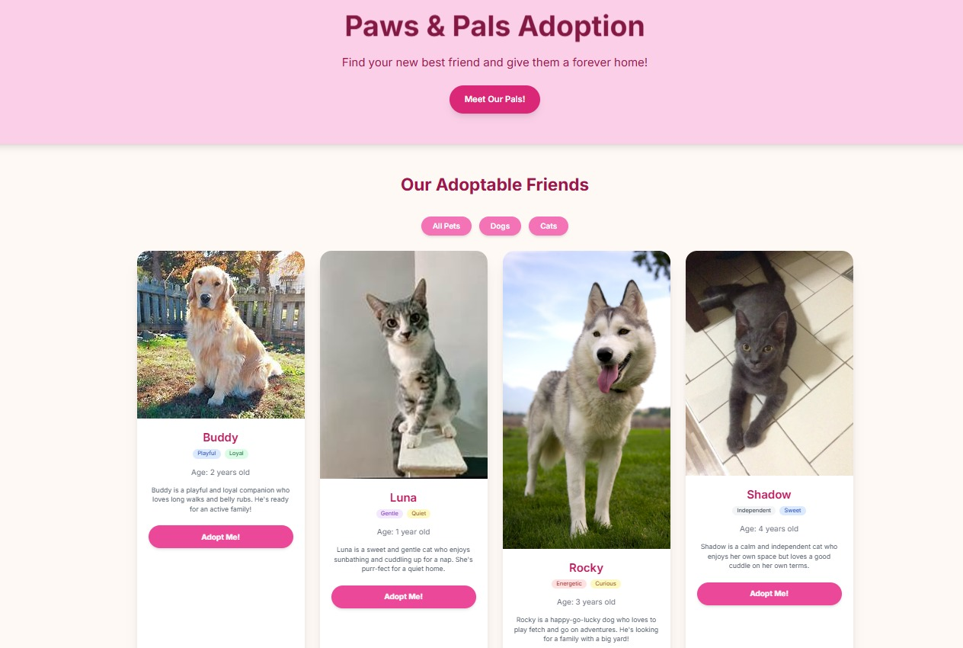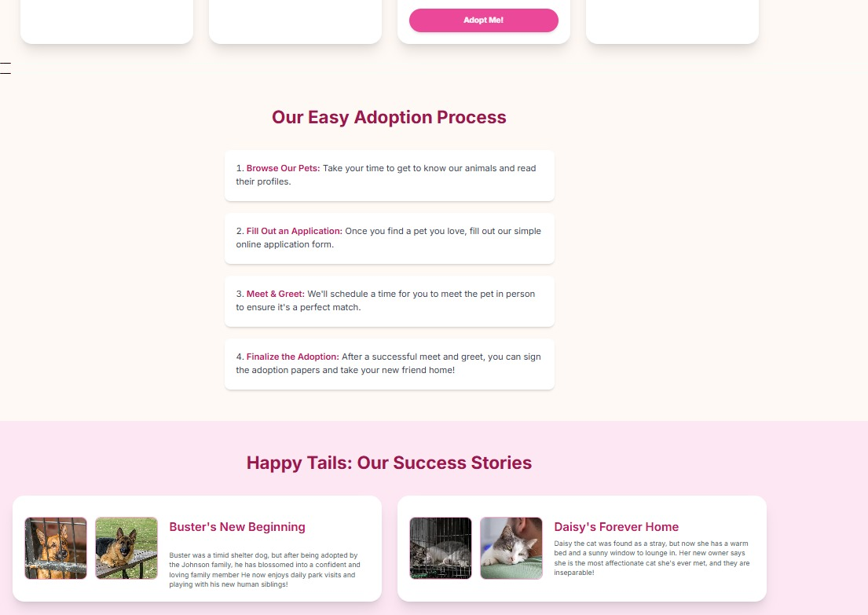

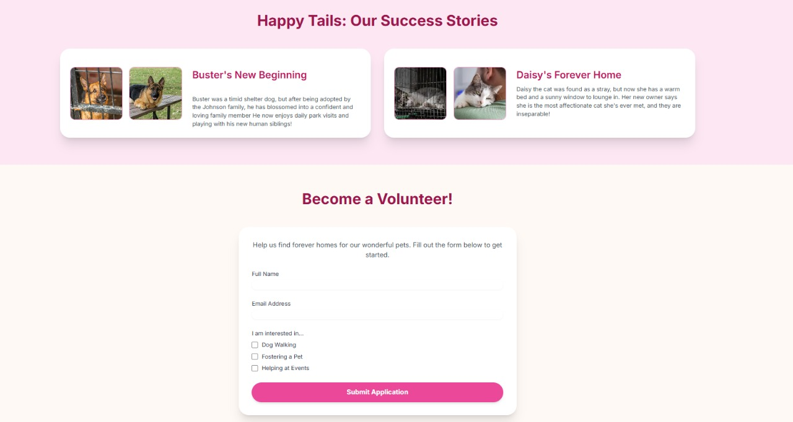

**CONCLUSION**

The Paws & Pals – Pet Adoption project serves as a demonstration of effective front-end design, created entirely with HTML and CSS. It presents a clean, responsive, and user-friendly interface that showcases the concept of a pet adoption platform. Through this mini project, I strengthened my skills in front-end development, focusing on semantic markup, responsive layouts, and visual hierarchy. I also gained valuable practical insights into designing for multiple devices, maintaining consistent styling, and ensuring accessibility without relying on external libraries or JavaScript. The hands-on process of implementing design principles enhanced my understanding of user-centric web design, emphasizing clarity, ease of navigation, and overall aesthetic appeal. This project not only improved my technical abilities but also provided a strong foundation for building more complex and interactive web applications in the future.

**REFERENCES**

* L&T LMS:<https://learn.lntedutech.com/Landing/MyCourse>